

**Mood Visualiser**

**USABILITY AND EXPERIENCE TESTING QUESTIONNAIRE**

This document is to be completed after the use of the Mood Visualiser system. Please return this questionnaire to **Anand Subramaniam** at the end of the session. If you have any questions regarding the project or the use of your data, please email myself at [ec12016@qmul.ac.uk](mailto:ec12016@qmul.ac.uk) or the project supervisor Mathieu Barthet at [m.barthet@qmul.ac.uk](mailto:m.barthet@qmul.ac.uk).

**Centre for Digital Music,**

Schoolof **Electronic Engineering** and **Computer Science**

April 2016

Name:

Email:

Age:

Gender:

Occupation:

Music Track (calm, exciting):

*The questions below come in the form of statements. Please circle which answer best represents how you feel towards the statement.*

1. How often do you experience music with visuals?

|  |  |  |  |  |
| --- | --- | --- | --- | --- |
| Never | Rarely | Sometimes | Very Often | Always |

Please elaborate:

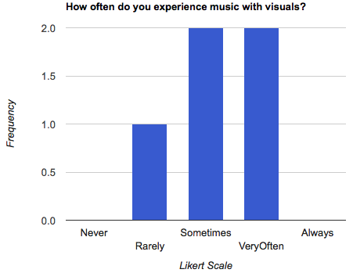

1. The visuals were different between the calm and exciting tracks

|  |  |  |  |  |
| --- | --- | --- | --- | --- |
| Strongly Disagree | Disagree | Neutral | Agree | Strongly Agree |

Please elaborate:

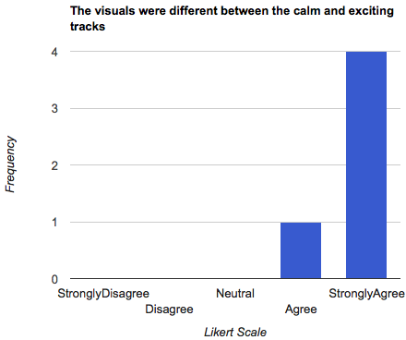

1. I was able to identify the relationship between the music and the visuals

|  |  |  |  |  |
| --- | --- | --- | --- | --- |
| Strongly Disagree | Disagree | Neutral | Agree | Strongly Agree |

Please elaborate:

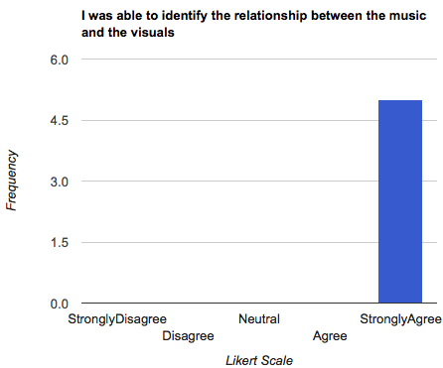

1. I was able to identify the relationship between the sensor and the visuals

|  |  |  |  |  |
| --- | --- | --- | --- | --- |
| Strongly Disagree | Disagree | Neutral | Agree | Strongly Agree |

Please elaborate:

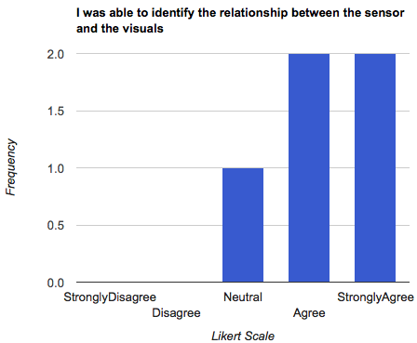

1. The sensor is comfortable and not distracting

|  |  |  |  |  |
| --- | --- | --- | --- | --- |
| Strongly Disagree | Disagree | Neutral | Agree | Strongly Agree |

Please elaborate:

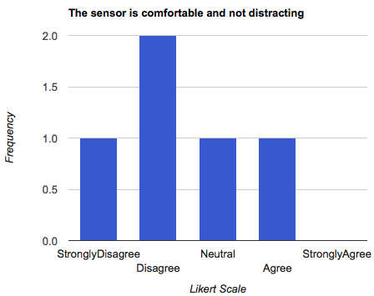

1. The web application was easy to use

|  |  |  |  |  |
| --- | --- | --- | --- | --- |
| Strongly Disagree | Disagree | Neutral | Agree | Strongly Agree |

Please elaborate:

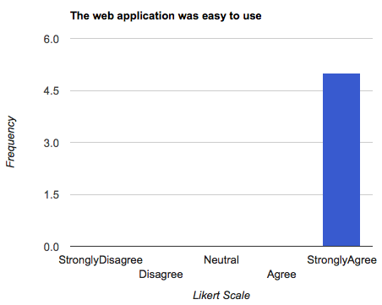

1. I enjoyed using the parameters of the app

|  |  |  |  |  |
| --- | --- | --- | --- | --- |
| Strongly Disagree | Disagree | Neutral | Agree | Strongly Agree |

Please elaborate:

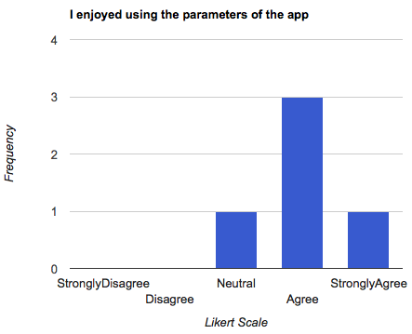

1. What did you like about the visuals?

Please elaborate:

1. Would you see yourself using such an application?

Please elaborate:

1. How would you improve the app?

Please elaborate:

If there are any additional notes or comments that you would like to make, please the space below to do so. Please be as specific as you can.

Additional notes/comments:

<http://www.rapidtables.com/tools/bar-graph.html>

*Thank you for your time and participation*